*Overview of voltage-Gated Potassium Channel and The Introduction of Its Selective Property*

**Abstract**

K+ channels, assuming for diverse functions through regulation of cells K+ permeability, are the most diverse of the channel families and are encoded by at least 78 genes. Voltage- gated K+ channels are the biggest parts of K+ channel family. They are important in the generation and propagation of action potential. There are already many previous researches on voltage-gated K+ channels to determined their biochemistry properties. In this article, we will give an overview of Voltage-gated K+ channel and discuss selective permeability of voltage-gated K+ channels.

**Introduction to** **Voltage-Gated K+ Channel**

Voltage-gated K+ channels mainly exist on the membrane of cells which can generate action potential. They are sensitive to potential change across plasma membrane. After suprathreshold stimuli act on excitable cells, voltage-gated Na+ channels and voltage-gated K+ channels will both be acted. Na+ channels change their conformation more rapidly than K+ channels, so Na current create the rising phase of action potential, whereas K+ current create falling phase. Therefore, this prosses indicates that voltage-gated K+ channels contain two interesting properties: voltage-gate and K+ specific permeability.

However, the researches on voltage-gated K+ channel were resistant because it was difficult to find suitable material for cloning of K+ channel gene. Fortunately, genetic studies in the fruit fly *Drosophila melanogaster* found a kind of mutant fly called *Shaker* which shake their legs under ether anesthesia. Researchers predicted that these flies contain variant of disrupted voltage-gated K+ channels and used positional cloning of DNA corresponding to the *Shaker* mutant. Finally, they successfully cloned the gene of K+ channel and laid foundation of revealing of biochemical mechanism of K+ channels.

**Basic Structure of Mammalian Voltage-Gated K+ Channel**

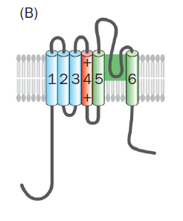From data of experiments, researchers have determined 3-D structure of voltage-gated K+ channel. (Fig.1)

**Figure 1**

Fig.1 is a schematic diagram of a single subunit of voltage-gated K+ channel. Four of this unit can for a whole K+ channel. This schematic diagram indicates that each subunit of K+ channel contains 6 transmembrane fragments. The fourth transmembrane fragment, involving the voltage sensitive property, is rich in residues with positive charge.

Fifth and sixth transmembrane fragments of each subunit construct a pore that allow ions to move across membrane.

**K+ Channel Selectivity**

K+ channels are highly permeable to K+ ions, whereas Na+ ions cannot pass. Chemical characteristic of K+ and Na+ indicate that they contain the similar positive charge but Na+ is smaller than K+. It is quite extortionary that K+ channel is permeable to larger ions but not to smaller ions. Hence, there must be special mechanism involved this property.

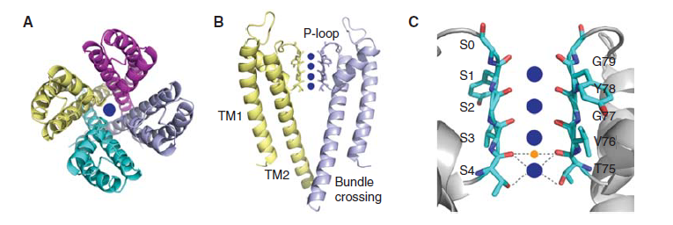Further crystallography studies of KcsA prove a breakthrough to reveal this mechanism. KcsA is K+ channel in E. coli. It plays a role as K+ channel in eukaryotic organisms, whose structure (Fig.2) highly resemble to voltage-gated K+ channels though it isn’t sensitive to potential change. Fig.2 B and C indicate details of pore domain of K+ channel. Notice that there are fragments called P-loop on carboxyl terminus in Fig.2 B, which is important for selectivity of K+ channel. P-loop construct by sequence of **T75V76G77Y78G79**. P-loops from different subunits form the **selective filter** of the channel and construct a narrow pore. The oxygens of the backbone carbonyls of T75, V76, G77 and Y78 are marked in orange (Fig.2 C), and direct toward the interior side of the pore.

**Figure 3**

**Figure 2**

As we know, water is great solvent for ions which form a molecule cage around each ion. Hence, ions are hydrated in solution. Oxygens located on P-loops can interact with K+ in the selective filter to mimic the character of water. Each K+ ion is surrounded by eight oxygen atoms. (Fig. 3) From the crystallography data, the distance between oxygens is quite suitable for K+ to adequately mimic water (Fig. 2 C), whereas too far for Na+. In this case, Na+ ions are not able to pass the selective filter. The narrowest part of the filter is with dimension of 0.3nm, which provide the entrance of large ions such as Cs+ ions.

**Figure 4**

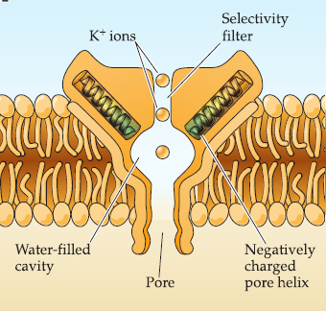In addition, if K+ ions wants to pass the channel, they must be dehydrated. On intracellular side of TM1 (Fig. 2 B), there are many residues with negative charge. For intracellular K+ concentration is higher than extra-, K+ ions tend to flow to the surrounding. First, K+ went into the cavity of channel (Fig. 4). This cavity evidently collects K+ from the cytoplasm and, utilizing negative charges from the protein, allows K+ ions to become dehydrated so they can enter the selectivity filter.

**Figure 4**

**Summary**

Voltage-gated K+ channels perform lots of crucial physiological functions based on its various properties. It is an important task for biochemistry research to reveal the biochemical mechanisms for the properties. The selectivity of K+ channel is a great example to explain property through biochemical analysis. Researchers determined the structure of K+ channel, which finally established an excellent model to explain the selective property through biochemical logic.

Biochemistry is the basic of all other subjects in biology. It gives us basic logic of life to elucidate biology phenomenon.

**Reference**

[1] Dorothy M. Kim and Crina M. Nimigean.Voltage-Gated Potassium Channels: A Structural Examination of Selectivity and Gating[J]. Cold Spring Harbor Laboratory Press,2016,:.

[2] David L. Nelson,Michael M. Cox.Lehninger Principles of Biochemistry[M].W. H. Freeman and Company:,2017:.

[3] Luo Liqun.Principles of neurobiology[M].Garland Science, Taylor & Francis Group, LLC:,2015:59-65.

[4] George J. Augustine, Ph.D. David Fitzpatrick, Ph.D. William C. Hall,etc.NEUROSCIENCE, Fifth Edition[M].Sinauer Associates, Inc.:,2012:66-69.

[5] Aggarwal SK, MacKinnon R.Contribution of the S4 segment to gating charge in the *Shaker* Kþ channel.[J].Neuron,1996,:1169-1177.

[6] Montoya E, Lourdes Renart M, Marcela Giudici A,etc.Differential binding of monovalent cations to KcsA: Deciphering the mechanisms of potassium channel selectivity.[J].Biochim Biophys Acta Biomembr.,2017,:779-788.